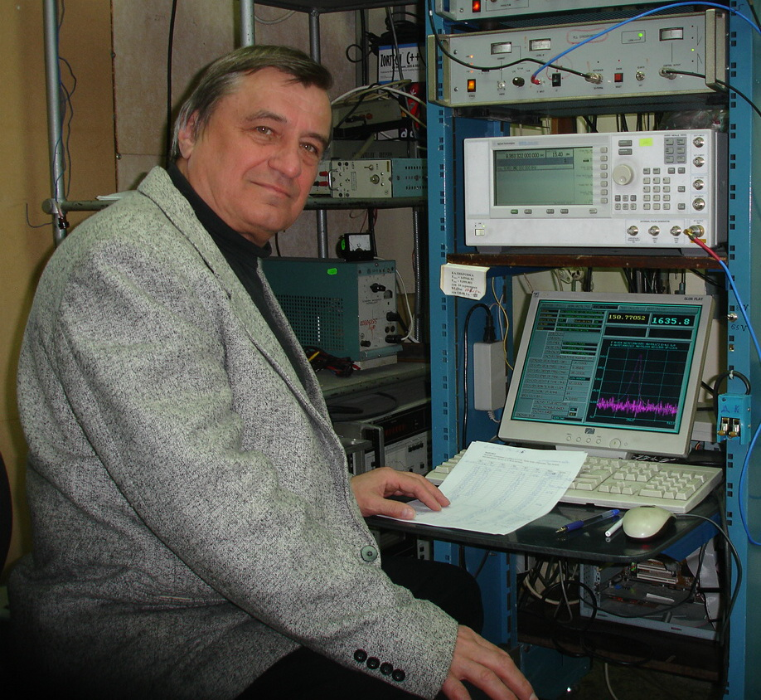
Vladimir V. Parshin, born Dec. 19, 1948; graduated from Radio physical faculty of Gorky State University in 1972. From 1973 to 1977 he worked as an engineer in the Radio physical Scientific Research Institute in the field of millimetre wave radars. In 1977 he changed for Institute of Applied Physics where he works at present as senior scientist. He specialises in quasioptical and waveguide science and technique at MM and SubMM ranges. He actively worked on the development of microwave technique for active and passive remote sensing of environment and investigation of microwave emission from Earth substrates for navigation purposes and participated in a lot of expeditions aimed to testing of corresponding facilities.
During recent 20 years V. Parshin gradually concentrated his activity in the field of precise resonator microwave spectroscopy. He has measurement facilities, based on the open Fabry-Perot resonators, allowing the measurement of extremely low losses at MM/SubMM-waves in wide temperature interval. Alongside with it he worked in the creation and investigations of materials with outstanding properties especially for high power windows (programme ITER).
The main aspects of activity now are: The development of new methods of measurements; The precise spectroscopy researches of the broad class of solid, liquid dielectrics and metals mirrors reflectivity (programme ITER); Reflectivity investigations of cooled satellite antennas (projects "Hershel", "Plank", "MADRAS", "Millimetron"), satellite antennas for high-temperature (project "BEPI COLOMBO"), ground based telescopes (projects "SUFA", "ALMA"); Real atmosphere absorption investigation (including continuum) for development of precise atmosphere propagation models.
The latest achievement is the creation of unique MM/SubMM-wave resonator spectrometer for the metal reflectivity investigation at LH temperatures and atmosphere absorption investigations in full real atmosphere pressure and temperature conditions; the first observation of resolved rotational spectrum of water dimer at equilibrium.

Projects and Grants awarded:
Principal Investigator of the Projects in the framework of Russian State Programs in Science and Technology, including:
“Development of Technology of Precise Measurements of Dielectric Properties in Microwave Bands” (the State Program “Physics of Microwaves”).
“The Meter of Low Absorption in Dielectrics in MM and SubMM Wave Bands” (the State Program “Construction of Scientific Apparatus”).
“Development of Super-High Resolution Methods of SubMM Spectroscopy” (the State Program “Quantum and Non-Linear Processes”).
INTAS project: “Mechanisms of Millimeter Wave Losses in Diamond and Diamond-Like Materials”.
Principal Investigator and Co-Investigator of ~20 Grants of “Russian Fund of Fundamental Research” including joint Russian-Chinese projects supported by the RFBR and the National Natural Science Foundation of China (NNSF):

Dr. V.V. Parshin has more 300 scientific publications.
Presentations in recent 20 years (including ~20 Invited Talks) at more than 35 International Conferences in Europe and USA.

Some selected references of last years

- Yu.A.Dryagin, V.V.Parshin. "A method to measure dielectric parameters in 5-0,5 mm wavelength band". International Journal of Infrared and Millimeter Waves. V. 13, N.7, pp.1023-1032, 1992.

- V.V.Parshin, R.Heidinger, B.A.Andreev, A.V.Gusev, V.B.Shmagin. Silicon as an advanced window material for high power gyrotrons. Int. J. of Infrared and Millimeter Waves. Vol.16, No.5, pp. 863-877, 1995.

- A.F.Krupnov, M.Yu.Tretyakov, V.V.Parshin, V.N.Shanin, S.E.Myasnikova. “Modern Millimeter-Wave Resonator Spectroscopy of Broad Lines”. Journal of Molecular Spectroscopy. V. 202, pp. 107–115, 2000.

- B.M. Garin, V.V. Parshin, S.E. Myasnikova, V.G. Ralchenko. "Nature of millimeter wave losses in low loss CVD diamonds" "Diamond & Related Materials". V.12, No. 10-11, pp. 1755-1759, 2003.

- V. Parshin, B. Garin, S. Myasnikova, A. Orlenekov, “Dielectric losses in CVD-diamonds in the millimeter-wave range at temperatures 300-900 K”. Radiophysics and Quantum Electronics. V. 47, N.12, pp. 974-981, 2004.

- S.-A.Boukabara, S.A.Clough, J.-L.Moncet, A.F.Krupnov, M.Yu.Tretyakov and V.V.Parshin. Uncertainties in the Temperature Dependence of the Line-Coupling Parameters of the Microwave Oxygen Band: Impact Study. IEEE Trans. on Geoscience and Remote Sensing. V.43, No.5, pp. 1109-1114, 2005.

- O.S. Mocheneva and V.V.Parshin. Scattering by structural inhomogeneities of CVD-Diamonds in the 100–1000 GHz range. Radiophysics and Quantum Electronics. Vol. 50, No. 12, pp. 946-954, 2007.

- A.A. Vikharev, G.G. Denisov, Vl.V. Kocharovski, S.V. Kuzikov, V.V. Parshin, N.Yu. Peskov, A.N. Stepanov, D.I. Sobolev, M.Yu. Shmelev. A High-Speed Quasi-Optical Wave Phase Switch Based on the Induced Photoconductivity Effect in Silicon. Technical Physics Letters. V. 33, No. 9, pp. 735–737, 2007.
ISSN 1063-7850, © Pleiades Publishing, Ltd., 2007.

- Vladimir Parshin, C.G.M. van‘t Klooster, E.A. Serov. Antenna Reflectors Reflectivity at 100 - 350 GHz and 80K. Proceedings of 30th ESA Antenna Workshop on Antennas for Earth Observation, Science, Telecommunication and Navigation Space Missions. pp. 353-356. ESA/ESTEC Noordwijk, The Netherlands May 27- 30, 2008. Invited.

- Parshin V. V., Tretyakov M. Yu., Koshelev M. A., Serov E. A. Instrumental complex and the results of precise measurements of MM and SubMM wave propagation in condensed media and atmosphere. Radiophysics and Quantum Electronics. V. 52, No. 8, pp. 525-535, 2009.

- S.N. Vlasov, V.V. Parshin, E.A. Serov. Method of thin dielectrics films investigation in MM wave region. Technical Physics. Vol. 55, No.12, pp.,1781-1787, 2010.

- M.A. Koshelev, E.A. Serov, V.V. Parshin, M.Yu. Tretyakov. Millimeter wave continuum absorption in moist nitrogen at temperatures 261–328 K. Journal of Quantitative Spectroscopy & Radiative Transfer. 112 (2011) pp. 2704–2712.

- Gregory G. Denisov, Alexey V. Chirkov, Vladimir I. Belousov, Alexander A. Bogdashov, Galina I. Kalynova, Dmitry I. Sobolev, Yury V. Rodin, Evgeny M. Tai, Vladimir I. Ilin, Sergey Yu. Kornishin, Maxim L. Kulygin, Vladimir I. Malygin, Elena A. Soluyanova, Vladimir V. Parshin, Michael Yu Shmelev. "Millimeter Wave Multi-mode Transmission Line Components" J Infrared Milli Terahz Waves. pp. 343–357, 2011.
DOI 10.1007/s10762-010-9756-3

- Vladimir Parshin, Evgeny Serov, C.G.M. van ‘t Klooster. "Precise measurements of Materials and Media in the MM/SubMM Ranges". Conference book of The 6th European Conference on Antennas and Propagation. (EuCAP 2012.) Prague, Czech Republic, March 26-30, CMO1.9, 2012.

- V.V. Parshin and E.A. Serov. Resonance method for studying dielectric liquids in MM and SubMM ranges of wavelengths. Radiophysics and Quantum Electronics, V. 54, No 8, pp. 632-637, 2012.
DOI: 10.1007/s11141-012-9324-x.

- B.M Garin, V.V. Parshin, V.I. Polyakov, A.I. Rukovishnikov, E.A. Serov, o.s. Mocheneva, Ch.Ch. Jia, W.Z. Tang, F.X. Lu. "Dielectric Properties and Applications of CVD Diamonds in the Millimeter and Terahertz Ranges". Chapter in the Springer publ. house: Recent Advances in Broadband Dielectric Spectroscopy.
Y.P. Kalmykov (ed.), Chapt. 6, pp. 79-87, NATO Science for Peace and Security Series B: Physics and Biophysics DOI 10.1007/978-94-007-5012-8_6, © Springer Science+Business Media, Netherlands, Dordrecht, 2012.

- V.V. Parshin, M.Yu. Tretyakov, M.A. Koshelev, E.A. Serov. Modern resonator spectroscopy at submillimeter wavelengths. IEEE Sensors Journal. V.13, №1, pp. 18-23, 2013. DOI 0.1109/JSEN.2012.2215315.

- M.Yu. Tretyakov, М.А. Koshelev, I.N. Vilkov, V.V. Parshin, and Е.А. Serov. Resonator spectroscopy of the atmosphere in the 350–500 GHz range. J. of Quantitative Spectroscopy & Radiative Transfer. V.114, pp. 109-121, 2013. DOI: 10.1016/j.jqsrt.2012.08.019.

- M.Yu. Tretyakov, E. A. Serov, M. A. Koshelev, V.V. Parshin, and A. F. Krupnov. Water Dimer Rotationally Resolved Millimeter-Wave Spectrum Observation at Room Temperature. Physical Review Letters. PRL 110, 093001, 2013. DOI: 10.1103/PhysRevLett.110.093001

- V. V. Parshin, E. A. Serov, G. M. Bubnov, V. F. Vdovin, M. A. Koshelev and M. Yu. Tretyakov. “CRYOGENIC RESONATOR COMPLEX” Radiophysics and Quantum Electronics. Vol. 56, No. 8–9, January, 2013. (Russian Original V. 56, No. 8–9, pp. 614-621, 2013

